W2D1 Homework

1.

• Collections – It consists of static methods that can function or return collections.

• Collection –Is the root interface in the collection Hierarchy. Moreover, it represents a group of objects (elements). The collection either no duplicates or duplicates also, ordered and unordered.

• List – is an ordered Collection that may include duplicate elements. It has the following operations: Positional access, Search, Iteration, and Range-view.

• Set – is a collection that doesn’t contain any duplicate elements. It represents the mathematical set abstraction. It has the following implementations: HashSet, TreeSet, and LinkedHashSet.

• Map – is an unordered collection that associates a collection of element values with a set of keys. A map doesn’t contain duplicate keys. It represents the mathematical function abstraction. It has the following implementations: HashMap, TreeMap, and LinkedHashMap.

• ArrayList – is similar to Array but in ArrayList you don’t have to provide an initial size. Also, you can easily create object collections of your defined classes.

• LinkedList – is an implementation of List interface.You don’t have to initialize the size of the list. Linked list is a linear data structure where each element is separate object.

• HashMap – The order of the keys can be sorted but is in definite if it will retain the order.

• TreeMap – The order of the keys can be sorted and will retain in order.

2.

Write the output of the code.

Hello

Java

Learn

World

Hello

Java

Learn

World

Hello

Java

Learn

World

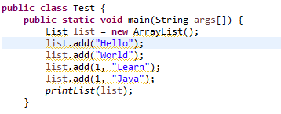

---LinkedList allows you to easily insert/delete anywhere in the structure while ArrayList is a list

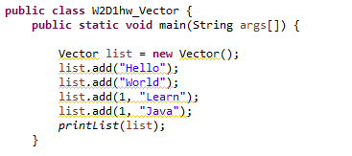

---ArrayList is not synchronized and Vector is synchronized.

3.

**Output:**

Hello

Learn

4.

1. Compile and run well, and output 3